**VBA HOMEWORK**

**STUDENT: HOA ROACH**

**Purpose:**

The purpose of this assignment was to code in VBA

**Challenge:**

VBA script is used to analyze real stock market data. This task requires the master and understanding of loop script to loop through all the stock for each year and then loop through all worksheets for all the years.

**Trends Discovered:**

The total stock volumn slightly decreased from 2014 to 2015 but then increased in 2016

**Screenshots:**

Testing data:

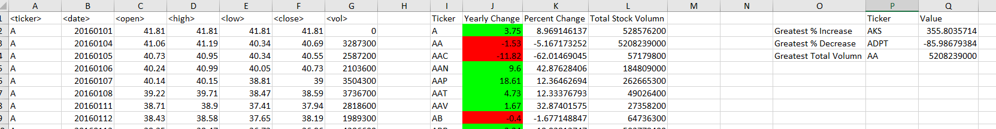

3 years: 2016, 2015, 2104

